

School Handbook
2024-2025

5830- 53rd St. Lacombe, AB T4L 0K6
Phone: (403) 782-7438 Email: los@wolfcreek.ab.ca
Website: www.los.wolfcreek.ab.ca



Revised: September 12, 2024

INTRODUCTION
Greetings from the Principal
Welcome to the 2024-25 school year!

We're excited to have you all back for another school year! Whether you're a returning student or new to our school, we hope you're ready for a productive year ahead. We look forward to celebrating with you, your accomplishments and the growth you'll experience. Remember to take advantage of all the resources and opportunities available to you, and don't hesitate to reach out to your teachers and staff for support. As long as you are committed to pursuing your education, we believe this year will be a success for you.

All the best!
Robert Reid
Principal
Lacombe Outreach School

Wolf Creek Outreach Schools
Mission/Vision and Beliefs Statement 2024-2025

Mission: To instill hope and inspire success for all learners.

Vision: Wolf Creek Outreach Schools are an extension of all Wolf Creek Public Schools and uphold shared vision and values. We ensure excellence in learning through a commitment to our beliefs and values, and a holistic methodology, which incorporates each learner’s social, emotional, physical, and psychological well-being.

BELIEFS - Through partnerships and collaboration of community, home, and school, we believe:

- All students can succeed.
- Relationships are the cornerstone of our schools
- Innovative Programming and high academic opportunities are critical.
  - We are continuously improving, exploring new approaches to literacy and enhanced learning
- In Flexible Learning Environments
  - We provide self-paced, individualized programming
  - We allow for flexible attendance
  - We provide flexible work spaces
- In providing a Safe and Caring Community (inclusive environment)
- In Achievement for Diverse Learners. Students who are:
  - At-risk
  - Upgrading
  - Home-schooling (or blended)
  - Independent living youth
  - Employed
  - Pregnant / parenting
  - Experiencing barriers (athletes, physical health, mental health, traditional school scheduling conflicts, etc...)

VALUES - Our values, based on our character attributes, are the foundation of our genuine relationships with students, parents, and each other. We value:

- “Working together” aspect with the traditional school with best placement decision for student success. This is a collaborative process reaching a collaborative decision in the best interest of the student’s educational and personal needs.
- Creating safe, positive climates for learning and working.
- Being compassionate and kind towards all members of our learning community.
- Being cooperative members of our learning community, committed to working collaboratively and valuing the contributions of others.
- Honesty by demonstrating integrity in our words and actions.
- Respecting differences and treating everyone fairly and equitably--we are inclusive!
- Treating others, ourselves and our environment with high regard and value, we are respectful.
- Being accountable and reliable in our actions and commitments. Through this, we model responsible citizenship.

When we love who we are and what we do, we are living what we profess.

Go to the Wolf Creek Public Schools website and look under policy and procedures for Admin Procedure 221 on Wolf Creek Public Schools Outreach Programs.

Lacombe Outreach School
Vision
To make a difference in the educational lives of learners ensuring success for all in a safe, caring, and educationally stimulating excellent learning environment.

Mission
Through the process of Excellent Learning Environments and a Collaborative Response Model embedded in a climate of respect, acceptance and encouragement, individuals achieve their personal and academic best. They achieve success!
Values
- Education for all students
- School is a safe and caring place to learn
- Respect is the foundation of all relationships
- Collaboration is a powerful strategy
- Our belief that second chances are not enough
- All students can be successful

Purpose of This Handbook
This handbook has been developed to provide students and parents/guardians with helpful information about Outreach Programs. It will also help students and parents/guardians understand the expectations we hold. Our students continually demonstrate that they can pursue our academic and behavioral expectations and are challenged to give their very best effort at all times. We look forward to you our students taking full advantage of the many learning opportunities we offer. Please do not hesitate to contact a member of the administration team if you have any questions or concerns.

Staff
Administrative Team
Mr. Robert Reid Principal
Mr. Darcy Blum Assistant Principal

Teachers
Mr. Scott Shimp
Mrs. Heather Bolin
Mr. Desmond Grabo
Mr. Rodney Prokopowich
Mrs. Christine Parent
Mr. Shawn Hollingsworth
Ms. Brooklyn F

Non-Teaching Staff
Mrs. Deanna Woodworth Administrative Assistant
Ms. Kenny McDougall Family School Liaison Worker
Ms. Robyn Devine Educational Assistant
Mrs. Sarah Wilson Educational Assistant

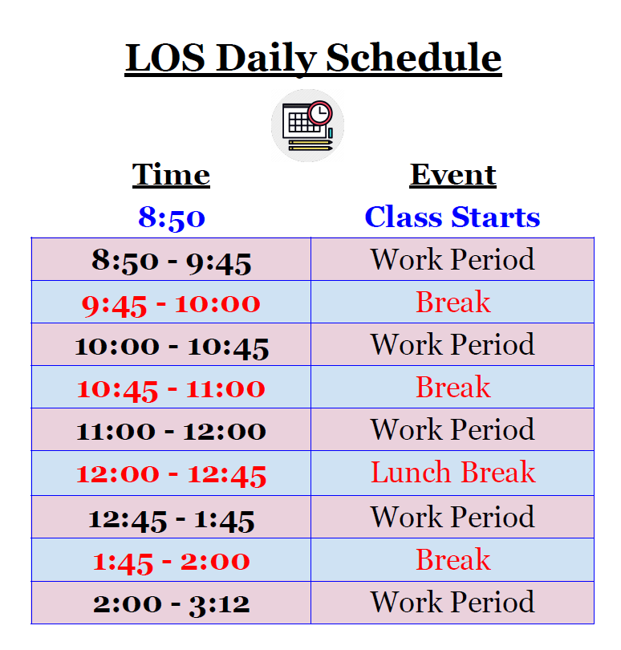

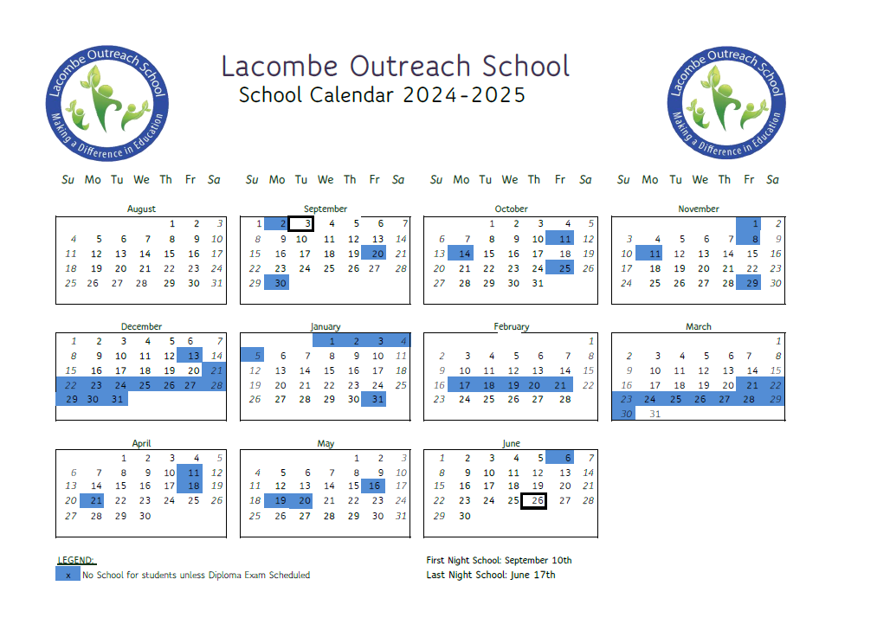

PROGRAM OF STUDIES
Alberta High School Diploma
A student must earn at least 100 credits to graduate from high school with an Alberta High School Diploma. Some workplaces or post-secondary institutions may require additional credits and/or specific courses.
Diploma exams are required in English 30-1 and 30-2, Social Studies 30-1 and 30-2, Mathematics 30-1 and 30-2, Biology 30, Chemistry 30, Physics 30, Science 30, Français 30-1 and French Language Arts 30-1. Final marks in these courses represent a blend of school and provincial exam marks. Talk to your teacher for more information about diploma requirements.

Alberta High School Diploma Requirements
EARN AT LEAST 100 CREDITS BY TAKING REQUIRED COURSES, PLUS OTHER COURSES THAT INTEREST YOU AND HELP YOU ACHIEVE YOUR GOALS.
REQUIRED COURSES:
• English 30-1 or 30-2
• Social Studies 30-1 or 30-2
• Mathematics 20-1 or 20-2 or 20-3
• Science 20 or 24 or Biology 20 or Chemistry 20 or Physics 20*
• Physical Education 10
• Career and Life Management (CALM)

EARN 10 CREDITS, IN ANY COMBINATION, FROM:
• Career and Technology Studies (CTS)
• Fine arts
• Second languages
• Physical Education 20 and/or 30
• Registered Apprenticeship Program (RAP) courses
• Knowledge and Employability courses; and

EARN 10 CREDITS IN ANY 30-LEVEL COURSE (IN ADDITION TO ENGLISH AND SOCIAL STUDIES), IN ANY COMBINATION, FROM:
• 30-level mathematics, science, fine arts, second languages, CTS, or physical education
• 30-level locally developed course (learn more about these course options through your high school)
• 30-level Work Experience
• 30-level Registered Apprenticeship Program (RAP)
• 30-level Knowledge and Employability courses
• Advanced level (3000 series) in CTS courses
• 30-level Green Certificate Specialization courses
• Special Projects 30

Graduation Ceremony Requirements
In order to participate in Graduation Commencement Exercises students must:
All students wishing to graduate must be enrolled in all their required courses (core and/or options) by the last school day of March. These courses need to be at least halfway completed and obtaining a passing mark by the end of the second week of May to be eligible for participation in graduation ceremonies.
Progress Reporting and Parent/Teacher Interviews
Students receive progress reports on a quarterly basis and upon request at any other time throughout the school year. In addition to these course reports, parents/guardians are encouraged to contact their child’s teacher if they have questions or concerns about their child’s progress.
Note: Grade 12 diploma exam results will be sent to students My Pass accounts in late February and July.

GENERAL OUTREACH PROGRAMS INFORMATION
Attendance and Punctuality
Attendance and punctuality are two important life skills. We expect students to arrive at school in accordance to their personalized learning schedule.
If a student is going to be away from school for a prolonged period, we would appreciate advance notification. This allows teachers time to gather any information and/or learning materials that can assist the student while they are away.

Attendance Policy
Our aim at Lacombe Outreach is to ensure that every student experiences success and it is our belief that following one’s attendance schedule is crucial for academic success. In order to maintain accurate attendance records, students are expected to ‘sign-in’ and ‘sign-out’ at the front desk.
We encourage parents/guardians to monitor attendance by contacting the school at any time.
Withdrawal Protocol
A student who has not handed in any modules will be sent a letter on the 30th day of inactivity, informing them they are in danger of being withdrawn. At the 45th day a student will receive another letter informing them they have two weeks to hand completed module(s) in or contact the administration. Students who are inactive for 60 days and have not responded to the correspondence will be automatically withdrawn.

Cellphones
Cellphones have been banned across Alberta in classrooms. They will be taken for the period if seen by staff. Although there are many legitimate reasons for students to have a cell phone at school, their unrestricted use can be a distraction to teaching and learning. They may be asked to turn in their cellphones at front desk if it becomes an issue.
Change of Address, Telephone Number
Many students have changes in their initial registration information during the year. Any changes to telephone numbers, address, emergency contacts and names should be reported to the Administrative Assistant as they occur so that accurate records can be maintained and in case of an emergency, someone can be contacted.
Child Welfare
Staff members have a responsibility, under the Child Welfare Act of Alberta (1985), to report cases of suspected child abuse and neglect to the proper authorities if it is believed that a child is in need of protective services.

School Social Worker
The Social Work/Family School Liaison Program offers support services and acts as a resource to families and individuals who may be experiencing difficulties at home or at school.
What is a School Social Worker or a Family School Liaison Worker?
The School Social Workers (SSW) and Family School Liaison Workers (FSLW) are available to enhance the development of a student's educational, social, emotional and behavioral experiences. The School Social Workers and Family School Liaison Workers are able to provide assistance to students on an individual basis and may also facilitate group/classroom sessions dependent on the needs in the individual schools. The School Social Workers and Family School Liaison Workers are a link to a variety of community agencies and advocate effectively in support of students and their families.
The goal of the School Social Worker and Family School Liaison staff is to ensure that:
· Families and students have effective Life Skills
· Families are connected to their schools and their community
· Collaboration with community agencies will enhance the wellbeing of students and their families
Some of the concerns that SWs and FSLWs can help with are:
· School-based concerns (e.g., motivation, classroom and attendance, school transitions, attention difficulties, etc.)
· Emotional concerns (e.g., anger, conflicts, self-esteem, worry, grief, sadness, etc.)
· Social concerns (e.g., peer conflicts, relationship concerns, friendship issues, etc.)
· Family concerns (e.g., separation/divorce, sibling conflicts, parenting strategies, lack of resources, home-school communication, etc.)
· Behavioral issues (e.g., safety issues, bullying, defiance, etc.)
· Other (e.g., physical/health related issues, pregnancy, alcohol/drug misuse, basic needs resourcing, advocacy, etc.)
Referrals can be made by:
· Family Members
· School Staff
· Students themselves
· Peers

COMMUNICATION
General Information
• Communication between parents/guardians and school personnel is an important dimension of any school
• It is our desire to establish excellent two-way communication
• Your support and your reports to us are of great benefit in our joint effort to provide your child with a sound education
• We encourage all parents/guardians to initiate contact with the school at any time with concerns or suggestions
• The quickest way to resolve a potential problem is to have everyone concerned aware of the issue
• remember, we have the same goal: to provide a quality education for your children in a happy, positive and safe environment
• Please feel free to share your thoughts, concerns and suggestions with us

Community Relations and Responsibilities
In keeping with Outreach “Be a Good Neighbor” policy, students are expected to maintain good relations with our surrounding neighbors and community. We expect that students do not loiter in, or around, business establishments, nor trespass on or litter private property. Thank you for keeping our School and community free of litter and for maintaining a positive image within our community.
Contraband
Contraband items including but not restricted to the following items are not permitted on Lacombe Outreach.
Property: firearms, alcohol, cigarettes, vaping, e-cigarettes and illegal drugs. In addition to this, an item is considered contraband if it represents undue exploitation of sex, vulgarity, violence, etc.

Dress Guidelines
Understanding the way we dress is personal and unique to each individual, LOS asks each student and staff to consider the choices they make for clothing and accessories in the school setting.

- Students and staff are asked to use good judgment in what they wear to school.
- May not wear anything that promotes or symbolizes drugs, alcohol, illegal activity, hate or discrimination, profanity, pornography; or that incites violence or harassment; or threatens health and safety.

Drugs and Alcohol
Outreach Programs has a zero-tolerance policy regarding drugs, alcohol or any other illegal substance. Students shall not be in possession of, or under the influence of illegal drugs, alcohol, or any other illegal substance in school or on the school property or at any other school sponsored activity. Violation of this policy will result in an appropriate consequence with the possibility of further disciplinary action in accordance with district policy.

Fees
The fee schedule for the 2024- 2025 school year is listed below:

Materials Fee $90
Upgrading prior to Sept 30 $150.00
Upgrading after Sept 30 $250.00
Adult $700.00

Homework
Research on improved student achievement clearly shows that students who do homework on a regular basis achieve better academic grades. Research also shows that achievement increases when parents/guardians provide support by:
• establishing a place free of distractions to concentrate on homework
• helping to prepare a clear and systematic homework schedule
• checking to ensure that the required homework is completed
• contacting your child’s teacher with any concerns

It is virtually impossible to have “no homework today” because a variety of activities are included as homework. Some of these activities are:
• reading books, newspapers, magazines, and periodicals
• reviewing modules to reinforce major concepts learned at school
• researching for long-term projects
• studying for quizzes and major exams
• practicing new skills and processes
• completing module work

We expect all students to accept responsibility for completing their modules and assignments in a timely manner. We also expect students to take pride in their completed work (quality, neatness, and timeliness).

Lacombe Outreach Property
• Students are expected to treat the Lacombe Outreach premises with a strong sense of school pride.
Accepting this responsibility will help to maintain a clean, pleasant and healthy environment.
• Any damage, accidental or intentional, should be reported to the Administrative Assistant. Depending on the circumstances of the damage the student may be liable for such damage.

Personal Property
• Students are responsible for all personal property
• Money and other valuables found on the Lacombe Outreach premises are to be turned into the
Administrative Assistant
• Unclaimed articles will be forwarded to a charitable organization

Physical Affection
Excessively overt displays of personal physical affection are not acceptable forms of public behavior within our school environment. Students are asked to exercise discretion while at the Lacombe Outreach School.

Physical Disability
It is urged that parent(s)/guardians or a physician provide the school with a written statement concerning the
Disability of a student, regardless of whether the disability is only temporary, or of a more permanent nature.

Planned Activities during Regular Scheduled School Hours
(Celebrations, Events, etc.)
All co-curricular and social events which have been scheduled by Lacombe Outreach during regular school hours are designed to enhance the learning culture of our School. As co-curricular activities, they are a part of our programming for students.

Student Names – Custody Information
In some situations, if special agreements or restrictions exist concerning child custody, please notify the office of any visitation prior to the day for which they are scheduled.

Student Records
• Student records of attendance, achievement, program special services, promotion and vital statistics are kept and maintained by the school. These records are maintained in strictest confidence to respect the worth and dignity of each student.
• Parents/guardians of students under the age of 18 have a right to be informed as to the content of the educational record and receive an interpretation of such records by qualified school staff.
• Student surnames may be changed on a student record only if the parent or guardian present evidence to the school that the name has been changed legally, e.g. a new birth certificate, a statement from a lawyer.

Substitute Teachers
The expectations Lacombe Outreach has been based on common sense and respect for other people.
Therefore, it is expected that students will give the same consideration to substitute teachers.

Technology Code of Conduct
The following code of conduct is intended to help students and parents/guardians of Lacombe Outreach understand the appropriate and inappropriate uses of the Internet, e-mail, and the school network:
• The person in whose name the account is issued is responsible at all times for the proper use of that account.
• Our computer system is intended for the educational use of all our students and is available to support learning and enhance instruction.
• It is our general policy that all computers will be used in a responsible, efficient, ethical and legal manner.
• Failure to adhere to policies will result in the revocation of the user’s access privilege by the school network administration and may result in other penalties.
- Students will be receiving a copy of the Wolf Creek School Division Acceptable Use Policy early in the school year and we will require parents/guardians to sign this document prior to students signing onto a school computer. www.wolfcreek.ab.ca

Transfers Out
As soon as you know that you are going to leave Lacombe Outreach and move to another educational program or school, please inform your teacher and the administrative assistant.

On the last day of attendance:
• All Lacombe Outreach property such as borrowed textbooks must be returned.
• All debts which are owed to the school for such things as lost books have been paid

Visitors
All visitors to the Lacombe Outreach (including friends of the students and former students) must report to the Administrative Assistant when they first arrive in the building. Students are requested not to have out of school friends visit the building.

To ensure the comfort and safety of our students while the Lacombe Outreach is in regular session, students from neighboring schools are not permitted to visit the School. This rule also applies to Outreach functions and other activities held throughout the year.

SAFETY AND HEALTH
Accidents
Any student injured at Lacombe Outreach or while participating in any Outreach sponsored activities must report the injury immediately to their teacher or administrative assistant.
• First aid will be given to a student injured on the premises
• An accident report is filled out, and if the accident is serious, parents/guardians are notified immediately
• Every attempt will be made to contact parents/guardians or their designee listed on the registration document.
• If the injury requires professional attention, an ambulance will be called
• In rare instances, when a child must be transported by ambulance to a hospital and parents/guardians cannot be contacted, a Lacombe Outreach staff member will accompany the student until a parent/guardian arrives at the hospital.

Emergency Drills (See Hour Zero) Hour Zero Link
A variety of drills are practiced several times a year. The students and staff are expected to know proper protocols for the various drills.

Emergency protocols include:
• Follow instructions and/or protocol of staff
• Everyone is required to leave the building during a fire drill
• Once outside Lacombe Outreach School, report to muster site.
• Cellphones are not to be used during an emergency drill.
• During drills students are to act in a quiet and orderly manner.

Illness at School
Students who become ill during the school day should notify their teacher or administrative assistant. If a student appears to be seriously ill, the parent/guardian will be notified, and the student will be allowed to go home accompanied by the parent/emergency contact.

Medical Conditions
Students with severe medical conditions or those who are on prescribed medication, which may affect their performance or safety at school, should notify their teacher or administrative assistant. A confidential record of student medical problems is kept on file with the Administrative Assistant.

STANDARDS OF BEHAVIOUR
It is our desire to see a respectful spirit in the actions and activities of our students. Respect for one another in our community is a manifestation of that spirit.
A major premise upon which our philosophy and practice is based is that each individual is worthy of personal consideration and should be treated with dignity and fairness. Established standards of behavior involve policies regarding safety and reflect statutory law. All policies are designed to ensure a quality teaching and learning environment. Established policies are enforced consistently and fairly.

Appropriate consequences will be administered to those students choosing to disregard established rules and regulations. Consequences are intended to be positive and logical. Parents/guardians will be informed when school-administered consequences appear to have little or no effect. Chronic disregard for school policies may result in a change in programming that could include transfer away from Lacombe Outreach.

At Lacombe Outreach we strive for student self-discipline and mutual respect between students, staff and parents/guardians. We emphasize that “students have a right to learn; teachers have a right to teach; and no one has a right to prevent this from happening.” We have high expectations of our students and we are confident that they can meet them. Each student will receive a School Code of Conduct at the beginning of the school year that they will read and sign.

Student Rights
• The right to voice and opinion in and appropriate manner. No one should interrupt another while she/he is speaking, or ridicule them for what they say. We should listen to each other.
• The right to be treated fairly by fellow students and teacher. We should treat each other with respect.
• The right to learn. No one should hinder another from learning. We will not waste time in class, distract or disturb others.
• The right to form our own friendships.
• The right to be accepted. No one should criticize or laugh at other for the way they look, walk, talk or act.
• The right to own property. No one should touch or take another individual’s property without his/her permission.
• The right to be safe. No one should physically hurt, threaten or verbally abuse another individual.
• The right to ask questions.
• The right to a name. We should address each other in a way that does not offend.
• The right to a clean and healthy environment. We should try to keep our school clean and tidy by not littering or vandalizing and leaving in good order the things and places we share.

Student Responsibilities
Courteous behavior and respect for the rights of others are among the most important student responsibilities. If a student is guided by concern for others and good manners, she/he will be able to assume these responsibilities as have the thousands of students who have attended Lacombe Outreach in the past.
At Lacombe Outreach students:
• recognize and respect the rights of students to learn and teachers to teach;
• demonstrate independent and cooperative work and study habits by completing all assignments thoughtfully and in a reasonable amount of time.
• strive for improvement in academic and personal development;
• know that a good effort is expected while at Outreach Programs;
• have respect for self, others and their property;
• contribute to a positive learning environment;
• recognize parents/guardians and teachers as partners in their education;
• learn responsibility, organization and self-discipline.

Intervention Strategies
At all times, the school promotes and encourages appropriate behavior patterns that are conducive to a good learning environment. As educators responsible for your education, we respect each student’s right to the best possible education. We expect students to cooperate with us in a respectful manner in order to achieve this goal. Any student who has difficulty in fulfilling his/her responsibilities will be subject to corrective action. This will include measures such as;
• Personal discussion with the student;
• contacting and/or meeting with parents/guardians;
• excluding a student from being on Lacombe Outreach premises for a set period of time;
• Other measures appropriate for the situation.

If required, the teacher will refer the student to a member of the school administration. There may also be occasions when the administration, teacher, parents/guardians and student meet to examine and resolve problems. Parental/Guardian cooperation is most important and can help to minimize a student’s difficulties.

A student’s behavior may be severe enough that it causes or creates substantial disruption or interference to other students or staff members. This kind of behavior may result in an “out-of-school suspension”.

a) The “out-of-school suspension” may be from 1 to 5 days in duration. Parents/guardians are contacted by telephone advising them of the suspension, and a letter summarizing the events that led to it is sent to them. A student conference is required before the student’s reinstatement to Lacombe Outreach.
b) Expulsion from the school or the District.

A suspension should not be regarded as a punitive act. A suspension is given to a student in order to remove him/her from a situation where his/her actions are detrimental to the welfare of himself/herself and/or others. The suspension gives Lacombe Outreach staff the opportunity to investigate the problem, to bring the problem into focus with the parents/guardians and student, and to seek a remedial course of action. The remedial
Course of action may involve the implementation of certain procedures within the Lacombe Outreach Programs site or the student may be placed at a different school in our District to allow a fresh start away from the source of difficulty.

Offences that could result in one of these courses of action include:
• possessing, using or transmitting any object that can reasonably be considered to constitute a weapon;
• possessing, using, selling, buying, transmitting, or concealing any alcoholic beverage, narcotic or hallucinogenic drug, marijuana, barbiturate, steroids, amphetamine, intoxicant, “look-alike” drugs, drug paraphernalia, etc.;
• Failure to comply with the smoking restrictions as established by the Wolf Creek Public School System;
• Any conduct threatening to use or counseling other persons to use violence, force, coercion, extortion, threats, intimidation, fear or disruptive means;
• Student involvement in fighting or any other form of violence;
• Blatant sexual behavior;
• Willful destruction of property and
• Other serious misconduct.

Concluding Remarks
It should be noted that discipline is infinitely complex, and every case is unique. Just as courts have leeway in determining consequences, so should school staff have leeway to exercise judgment in determining consequences for misdemeanors. Finally, discipline is not a responsibility of the school alone. Effort expended in trying to educate and encourage students to act positively must be a cooperative endeavor involving the home and school. It is hoped that together we will ensure the rights of all students to a productive educational environment in which they may learn the personal, social and academic skills necessary to develop into mature, happy responsible citizens accountable for their own actions.

Student Grievance Procedure
When misunderstandings arise between students and teachers or administration, the following grievance process is available to all students to resolve the problem:
1. When feasible, the student should meet with the teacher to discuss the issue. If the initial meeting does not resolve the situation, the parent/guardian may confer with the teacher involved.
2. If still unresolved, the matter should be referred to an administrator

LEARNING AND COUNSELLING SKILLS
Requirements for Success
In order to guarantee that your son or daughter will have a successful year at Lacombe Outreach the following responsibilities will have to be met:
• Student Requirements:
o Come to school with a positive attitude
o Be ready to succeed
o Attend regularly, a minimum of ten hours per week
o Complete all assignments
o Write all exams and tests

• School Requirements
o We guarantee your child the opportunity to have a successful year
o We guarantee a safe, clean, and positive environment
o We will make sure that at least one adult will know your child well

• Parental Requirements
o Check on your child’s progress on a regular basis (please phone and arrange a time to come in)
o Keep the school informed of how we are doing (please phone, write, or come in and tell us)
• Other Requirements
o Homework is an extension of the work you have done at school. Its purpose is to help you apply and reinforce what you are learning in class. Make it a habit to do homework on a regular basis.
o Home study broadens your horizons and helps you learn more about what you are learning in school.

Preparing for Tests, Quizzes, and Examinations
• Set up a study schedule to help you prepare for exams. Make a plan that will enable you to cover all the material you need to know.
• Avoid cramming. Begin your review well before the exam so you have enough time to memorize essential facts and information.
• Find out whether your exam will be essay-type or multiple-choice, and exactly what material will be covered on the test.
• For each subject, make a detailed list of all the topics for which you are responsible, then arrange them in order of importance. Follow this order in your review.
• Make up questions that you think could be on the exam, and then try to answer them.
• When you feel you are ready, have someone else quiz you on what you have studied.
• Get a good night’s sleep before the exam
Strategies for Successful Studying
1. Effective listening
• Concentrate on what is being said. Don’t allow noise or other people to distract you.
• When you don’t understand what is being said, ask questions.
• Be aware of implied meanings or ideas.
• Make notes about main ideas and summarize key points.

2. Taking notes
• Make notes in your own words rather than the teacher’s; listen for important facts and ideas, and don’t try to write down every word.
• Date your notes, and number the pages.
• Keep your notebooks neat. It is easier to study if your work is organized.
• Organize your notes as soon as possible after class.
• Keep all notes for one subject together.

3. Remembering What You Have Learned
• Briefly review each day’s notes every day. Have a weekly review in each subject.
• Summarize what you have read, heard, or discussed. This helps you to remember the material.
• Try to apply what you have learned as soon as, and as often as possible.
• Get into the habit of doing extra reading in the subject area you are studying.

4. When to Study
• Prepare a timetable showing when you will study and when you will be occupied with other commitments such as lessons or practices.
• Adjust your timetable so it works for you, setting up realistic goals.
• When doing long or difficult assignments, divide them up into shorter manageable units. Do not try to do the whole assignment at once or leave it to the last day.
• After finishing a unit of work, take a short break before continuing. This helps keep your mind on your work.
• After you have completed your rough copy for an assignment, wait a day before you edit it and begin the final draft.

5. Choosing a Place to Study
• Try to do your homework and studying in the same place every time.
• Make sure you have good lighting so you don’t tire your eyes.
• Use a firm, straight chair, not an easy chair or the bed.
• Study away from distractions such as loud music or the television. Soft background music may help you concentrate

Social Skills

Skill – Listening
1. Make eye contact
2. Use good body language
3. Pay attention to what is being said
4. Avoid interrupting

Skill – Ignoring Distractions
1. Decide what the distraction is
2. Say to yourself, “I’ll keep working”
3. Keep on working
4. Praise yourself on good self-control

Skill – Working Independently
1. Have all the materials you need with you
2. Work on figuring out things on you own
3. Ask for help if you cannot do it on your own, but still work while you wait
4. Stay focused on you work

Skill – Responding to a Request
1. Answer right away to let the person know you hear them
2. Answer politely
3. Decide if you can do it
4. Do it right away if you have agreed to

Skill – Using Self-Control
1. Think about the consequences before doing or saying anything
2. Use self-talk
3. If you need to, leave the situation as soon as possible
4. Praise yourself on good control

Skill – Accepting Consequences
1. Decide if you were wrong
2. Find out what the consequences will be
3. Apologize

