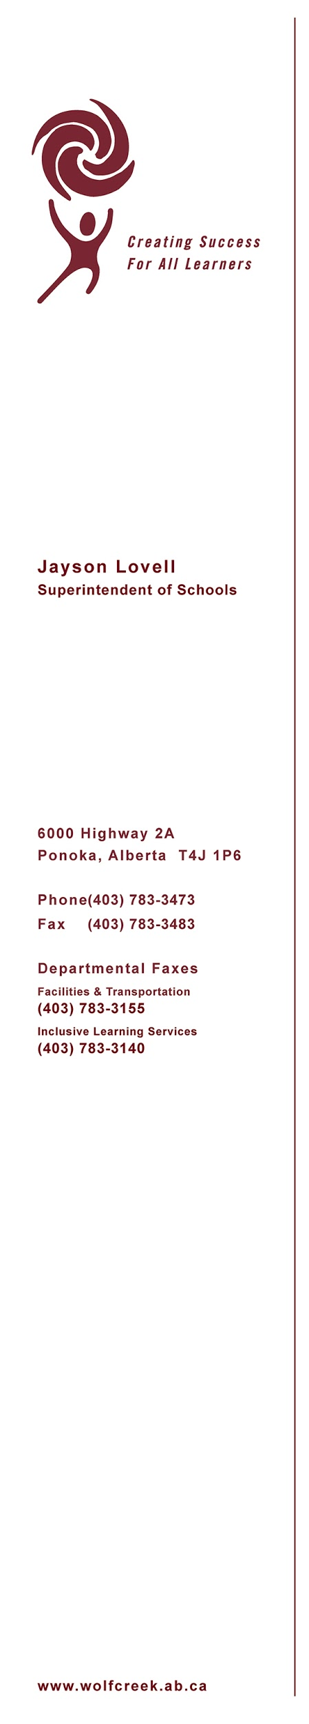

May 1, 2020

Re: Farewell or Graduation Events for May & June 2020

Dear Wolf Creek Student/Parent/Guardian,

Events like the end of Grade 9 (Farewell) and Grade 12 (Graduation) are special opportunities that students, parents, family, friends, staff, and community members look forward to celebrating together. During the COVID-19 pandemic, all ceremonies have been postponed across all schools in Wolf Creek Public Schools and the province due to the current Alberta Health restrictions on the size of gatherings.

After consulting with school administrators, direction has been provided by the district for farewell/graduation ceremonies. A decision has been made that any Farewell or Graduation event will be in one of two formats; a “virtual” ceremony (ie. videoconference) completed before the end of June 2020, or a traditional graduation event rescheduled into the new school year.

Collectively, we acknowledge the disappointment in having to change farewell/graduation ceremonies and celebrations. However, the final decision on how each Wolf Creek school will commemorate farewell/graduation will be determined by each school principal.

In rescheduling farewell/graduation ceremonies, all Wolf Creek schools will follow the lead and guidance of Alberta Health based on when it is safe to proceed. As such, some schools have tentatively rescheduled a graduation ceremony date for the fall, 2020 while other schools will be gathering feedback from graduates and parents to guide a decision on the most appropriate way to acknowledge their graduates. We recognize all rescheduled events in the fall are still uncertain and subject to cancellation or postponement pending restrictions for gatherings. Regardless of which format is chosen, our school division looks forward to that opportunity to celebrate the amazing accomplishments of our students.

In terms of students receiving graduation documents, students that complete the graduation requirements will still receive their high school diploma or certificate of completion and will be able to get transcripts on the Alberta Education MyPASS website: (https://public.education.alberta.ca/PASI/myPass/welcome). Alberta Education will mail diplomas to the students upon completion of graduation requirements. We encourage all students to continue to work towards completion of the tasks assigned by their teachers in the coming weeks.

We wish to thank all of our students and their families for their continued understanding and cooperation to ensure students remain safe and follow provincial guidelines during this time.
Sincerely,
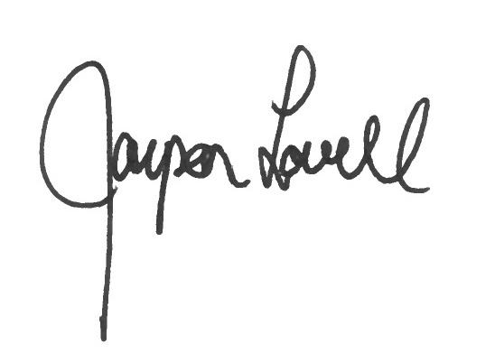
Jayson Lovell
Superintendent
Wolf Creek Public Schools

